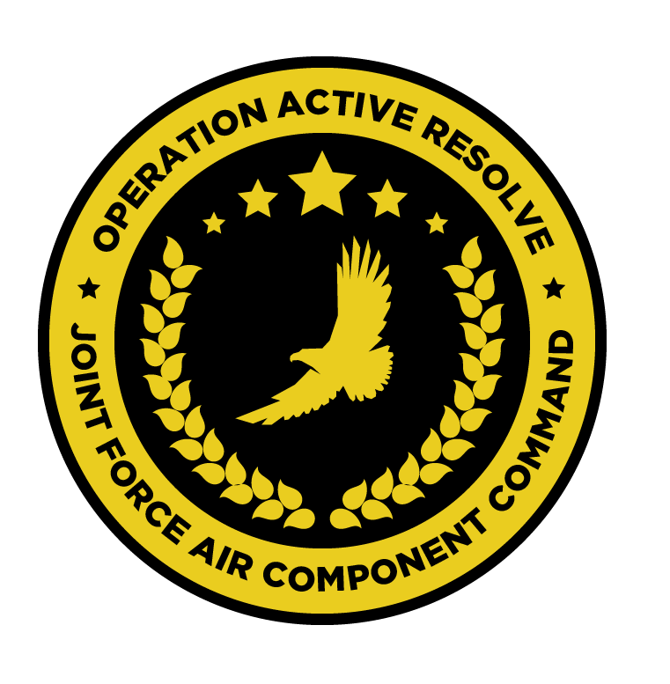

JFACC AIR OPERATIONS DIRECTIVE

OPERATION ACTIVE RESOLVE

D+10

# 1. SITUATION

## a. JFC guidance

(1) Priority of effort is on establishing Air Superiority in support of LCC in the northern sector. Start shaping for phase 2 in the operation For support to LCC, support shaping effort for LCC by removing enemy long range artillery, C2, logistics and artillery.

(2) Deploy forces to the region, building situational awareness (SA) of the situation and defend Turkey and Israel against Syrian aggression. Set conditions for CJTF land offensive into Syrian to destroy Syrian offensive capability. Phase ends when Syrian forces in Turkey and Israel have been defeated and Turkey and Israeli territorial integrity have been restored.

(3) JFACC is the supported commander.

See [CJTF Operations Order](https://132nd-vwing.github.io/OPAR-Brief/ORDERS/OPAR%20CJTF82%20OPERATION%20ORDER.pdf)

## b. Enemy situation.

Increased activity IVO PALMYRA. The last 24 hours have seen an increased activity of air activity in the vicinity of PALMYRA airfield. It is unclear to VIS what the activity is related to.

[VID INTREP D9](https://132nd-vwing.github.io/OPAR-Brief/INTELLIGENCE/VID/OPAR_VID_INTREP_D9.pdf),

All 1st Corps units have dug in hard near the front line to Turkey, and are showing no intention to give up easily. This is in line with the assessment VID INTREP D+9. Based upon INTEL VIS believes remaining 10th Armor Division (now battalion strength) has positioned themselves west of Minakh AB area, based upon the presence of Tunguskas in that area. Engagement during D+9 showed no signs of 11th Mechanized Division, but VIS is of the opinion that they are holding in the rear of 12th Mototrized Division which is still at almost full combat strenght. BM-21 GRAD presumed location have been plotted on the map, while URAGAN and SMERCH launchers are located further away from the Turkish/Syrian border.

ENY units of 1st Corps is anticipated to dig in hard protecting their home country. The presence of SA-15 in south eastern corner of KB MILLER gives high indication of high value targets such as HQ, 125th rocket artillery battalion which is still supported by SA-15. 105th & 115th rocket artillery battalions do not have support from SA-15’s. We can expect heavy bombardment from rocket artillery once stepping into Syria. It is vital that allied air forces neutralizes these rocket artillery units as they can inflict heavy casualties on allied ground forces. NOTE! 2nd Corps doesn’t not have full strength compared to a standard Corps as it lacks the following; Armor Division, Air Defense Division, Rocket Artillery Regiment.

1st Corps have withdrawn from Turkey. Lead elements of 2nd Corps have just been found in vicinity of Minakh AB. 3rd Corps is holding strong in GOLAN Heights region and currently VIS does not hold any new intelligence of this area.4th Corps is still believed protecting Damaskus.5th Corps is still believed stationary, however is expected to be able to move within days if needed. See [VIS INTSUM GROUND D+9](https://132nd-vwing.github.io/OPAR-Brief/INTELLIGENCE/INTSUM/VIS_INTSUM_D9_Ground.pdf) for details.

The Syrian IADS in the North Sector has been partially degraded by the loss of the SCC center in Abu Al Duhur and the backup center IVO Jirah AB.

Several key EWR sites remain operational despite CJTF efforts to destroy them.

Jirah AB remains inoperable and is estimated to remain out of operation until D+12.

SA11s remain a significant threat in the southern part of the North sector. With the restoration of Abu Al Duhur and continued operations out of Tabqa AB, the Syrian Air Force has been able to impede CJTF operations and negate air superiority despite loosing several search radars attached to key air defense sites.

It is estimated that the enemy air order of battle has been severely attritted based on assessments from reports. 4th Generation ( MIG-29 ) airframe numbers are estimated down to 49% of their original strength and all but 6 MIG-25 have been destroyed leaving them down to 25% strength.

Overall estimated 69% remain of Fighters/Interceptors and Bomber aircraft, limiting the ability to sustain offensive and defensive air operations.Based on sortie generation, It is LIKELY that Abu Al Duhur has been reinforced with an additional squadron of MIG21s. Intelligence suggests that the QRA reaction is 10 minutes from Abu Al Duhu(MIG21), Tabqa (MIG29), Marj RyhallAB (MIG23s) and Mezzeh AB ( MIG29s ).

SyrAFis able to conduct A-G sorties based on the aircraft inventory, although their operations are severely impeded by presence of CJTF fighters. SU-24s have observed operating in the AO as well as along the Syrian Coastline ( low level ). It is CONFIRMED that MIG29s based at Tabqa are being sortied for A-A role, but are otherwise a part of an A-G division, to meet CJTF strikes. Detection range of the Syrian Early Warning system appears to be just off the coast of Syria. The only known EW site that has the detection range necessary to activate QRA based on observed timings is based at Al Assad. See [VIS INTSUM D+9 IADS](https://132nd-vwing.github.io/OPAR-Brief/INTELLIGENCE/INTSUM/VIS_INTSUM_D9_IADS.pdf) for details.

## c. Friendly situation (by joint force component).

55th Division is static at the FLOT to prepare for assault into Syria in PHASE 2

56th Division is static at the FLOT to prepare for assault into Syria in PHASE 2.

**III Corps (southern sector)**

III Corps was planned to start its offensive at D+4. However, due to low attrition of the Syrian 3rd Corps the offensive is delayed. III Corps will start its offensive when conditions are set for starting the offensive.

Conditions set for offensive start is 35% attritionon the following enemy units:

-30th Armored Division (Syrian 3rd Corps)

-31st Mechaniced Division (Syrian 3rd Corps)

-32nd Motorized Division (Syrian 3rd Corps)

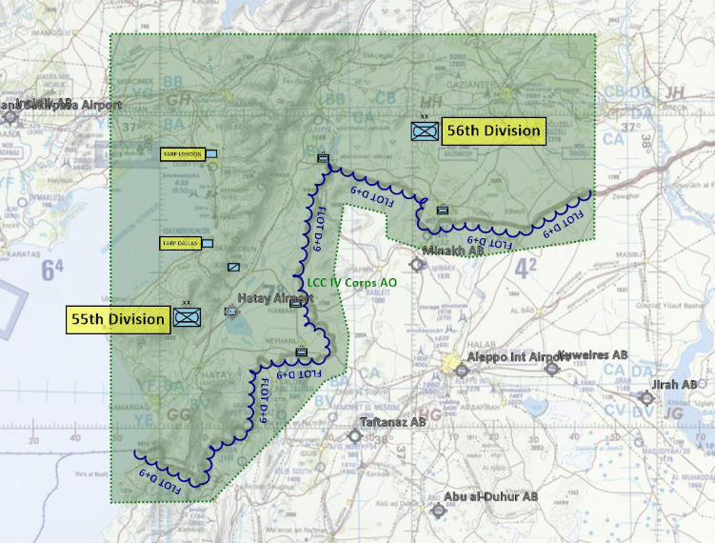

See also [CJTF Directions & Guidance D+10](https://132nd-vwing.github.io/OPAR-Brief/MISSION%20INFORMATION/CJTF_D_G/OPAR%20CJTF%20DIRECTION%20AND%20GUIDANCE%20D10.pdf)

# 2. MISSION The JFACC’s mission statement (verbatim).

JFACC will establish air superiority in the area of operations and defeat Syrian offensive capability in support of CJTF-82 offensive operations to neutralize Syrian offensive capability to conduct offensives in the region.

# 3. EXECUTION–AIR OPERATIONS

## a. JFACC’s intent.

JFACC intends to deny the use of Tabqa AB by 3rd and 4th generation aircraft for a period of at least 7 days. Support will continue to be provided to ground units operating in Sector NORTH whilst conducted AR to further attrit 12th Motorozed Division and neutralize MSLR/ARTY units.

**(1) Purpose.**   
Establish air supremacy in the North sector and deny the enemy the ability to impede CTJF operations. Provide direct support to friendly ground forces to set conditions for Phase 2.

**(2) End state.**   
● Tabqa Airbase is denied use for 7 days. 80% DPIs hit IAW JTPL D+10.

● 12th Motorized Division is attritted 50% and 105th and 115th Rocket Arty Battalion MSLR/ARTY units are neutralized.

## b. Execution:

Strike against Tabqa to be conducted from the northern border of Turkey as intelligence suggests that this avenue of approach will afford the greatest tactical surprise and force security.

## c. Focus of effort by objective.

Priority effort shall be focused on supported AI strikes against designated JTPL targets for D+10 in order of priorities therein.

## d. Allocation of sorties

NSTR

## e. Acceptable level of risk (ALR).

As per JPTL D+10. Otherwise as per SPINS.

## f. Collateral damage and civilian casualty guidance

IAW [Law of Armed Conflict](https://www.doctrine.af.mil/Portals/61/documents/Annex_3-60/3-60-D33-Target-LOAC.pdf). Suspected civilian casualties should be reported through the C2 network as soon as is practicable.

## g. TST guidance.

IAW SPINS/JPTL.

h. Intelligence, Surveillance, Reconnaissance (ISR) **–**

Presence of enemy air defence assets – ground- and air-based – must be reported as soon as practicable. Reports should, where possible, include the observing aircraft’s current position, a relative bearing to the threat and the type of threat.

Sensor taskings should be conducted where resources permit to identify the location and movements of enemy air defence assets and SCUD launchers/WMD. These locations should be reported as soon as is practicable.

Where possible, ELINT activities should be conducted to identify the locations of SAM threats. Priortize sorties of this kind in the East Sector.

## i. Other issues

NSTR

## j. Direction and Guidance

- Aircrews **must** remain clear of Jordanian and Lebanese airspace at all times. Munitions must not be expended which may encroach on either airspace.

- All flights follow: [Guide for filling BDA and INTEL for OPAR](https://www.dropbox.com/s/opxclf2r12j8ke2/Guide%20for%20filing%20BDA%20and%20INTEL.docx?dl=0)

# 4. ADMINISTRATION AND LOGISTICS

NSTR.

# 5. COMMAND AND CONTROL

IAW JAOP.